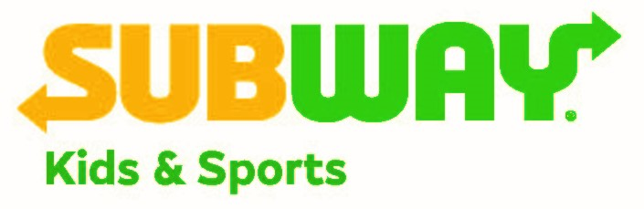

Subway Kids & Sports of Arizona Grant Request Application
Please answer the following questions about your organization in the space provided. Please feel free to provide additional data, photos or testimonials about your organization and the program requesting funds on a separate sheet – but answer these questions in WORD right here.

Please note that only 501c3 organizations that are not officially affiliated or benefiting a government entity or school program may apply. Please note that only those organizations specifically requesting funds that meet our mission will be considered. The mission of Subway Kids & Sports is to provide sports equipment, uniforms, registration fees and access to major sporting events for kids who might not otherwise be able to participate. Subway supports kids in sports because it believes basic sports skills - teamwork, commitment and accountability - help kids throughout their lives. Subway Kids & Sports has reached more than 40,000 Arizona children since its inception in 1999.

Applications will only be accepted via email.

Please submit the below application answers ONLY in WORD FORMAT to abailin@hmapr.com no later than February 28, 2018 at 5 p.m. to be considered. Please type all the answers in black, Times New Roman below. Feel free to take additional space, but do not change the formatting.

Additional data or supporting materials outside of this packet may be submitted in PDF format.

Please direct any questions to Alison Bailin Batz via email at abailin@hmapr.com or phone at 602-957-8881. Please do not call to request an extension on this above deadline.

- Organization’s name and year founded in Arizona:
- What is your tax identification number:
- Corporate office address:
- From what sources do you receive funding for your organization? List all that apply:
- Phone number, fax number, and email address:
- Your organization’s mission statement:
- Please provide details regarding the program, department, club, or organization you are requesting a grant for and how a grant from Subway Kids & Sports of Arizona would benefit it. Please feel free to include photos as well.
- How much money are you requesting and where would the money be directed?
(please note grants are generally requested from $500 to $5,000)
- Why should Subway Kids & Sports of Arizona donate to your organization?
- If you have been awarded a grant from Subway Kids & Sports of Arizona in the past, what impact did the funds have on your organization? For example, how many children directly benefited? Please feel free to provide photos or other materials.
- If you are requesting funds for a specific program, is this program ongoing, or is this the first time it’s being offered? How long will it last?
- Are there opportunities for use of the Subway Kids & Sports of Arizona logo on such items as banners, T-shirts, or other? Please describe.

